**Assignment 3 on Javascript**

1. Make a Rectangle class that stores a width and a height. Make a few instances and print out the properties. Modify a few of the properties and print out the results again.

2. Add a getArea method. Use the prototype property.

3. Assuming that the Rectangle constructor takes a width and a height, why does the following output 20 instead of 200? (Hint: if you see an answer that seems too obvious to be what I am looking for, it probably is the answer I am looking for.) Rectangle r = new Rectangle(4, 5); r.hieght = 50; r.getArea(); --> 20 // Not 200

Code:

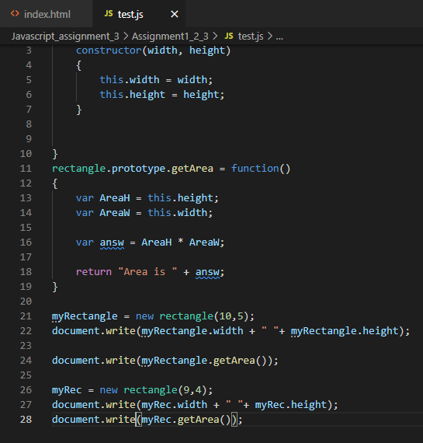

Output

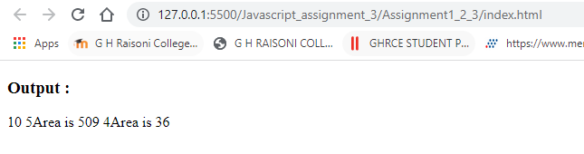

4. Make a variable whose value is an object with firstName and lastName properties, but don’t define a Person class first. Try looking up the first and last names. Try changing the last name. It seems very odd to Java programmers to make an object without first defining a class, but JavaScript programmers do this sort of thing all the time.

5. Try reading the middleName property from your variable above. Try assigning to the middleName property. Try reading the property again after you assign to it. Is this behavior a good thing or a bad thing?

Code:

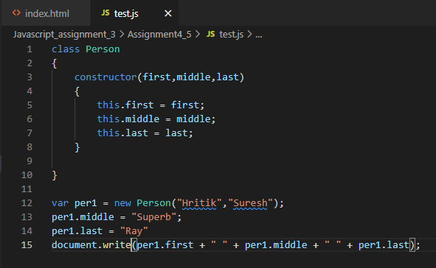

Output:



6. Create a string that contains what looks like an object with firstName and lastName properties. Use “eval” to turn it into a real object, and test it the same way you did with the previous object that you created directly.

7. Do the same with JSON.parse. You have to follow strict JSON rules in this case.

Code:

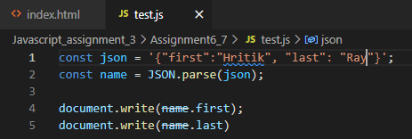

Output:

